

**Data Science Fundamentals**

Year 1 (2022/23), Semester 1

**SCHOOL OF INFOCOMM TECHNOLOGY**

Diploma in Cyber Security & Forensics

Diploma in Data Science

Diploma in Immersive Media

Diploma in Information Technology

Common ICT Programme

**ASSIGNMENT**

|  |  |  |
| --- | --- | --- |
| **Deadline:** | **Softcopy** | **31 July 2022 @ 2359 hrs** |
| **Hardcopy** | **Hardcopy to Tutor in class before presentation on Week 16** |

|  |  |
| --- | --- |
| **Tutor & Tutorial Group:** | Mr. Edgar Low  P08 |
| **Team Leader:** | Law Jun Jie (S10243668) |
| **Students' Name/Number:** | Akul Arun (S10243523)  John Wong (S10242004)  Pranav Vijitharan (S10243197)  Lee Jia Wei Shawn (S10239826) |

**Penalty for late submission:**

1. 10% of the marks will be deducted for everyday (inclusive of Saturdays, Sundays, and Public Holidays) after the deadline.
2. **NO** submission will be accepted after 7 August 2022 @ 2359hrs

**Contents**

1 Introduction 3

2 Company CEO 3

2.1 Stakeholder Background 3

2.2 Actionable Statements 4

2.3 Data Analysis and Visualisation 6

2.4 Dashboard 12

3 Marketing Manager 13

3.1 Stakeholder Background 13

3.2 Data Analysis and Visualisation 14

3.3 Dashboard 19

3.4 Actionable Statements 21

4 Sales Manager 22

4.1 Stakeholder Background 22

4.2 Actionable Statements 22

4.3 Data Analysis and Visualisation 23

4.4 Dashboard 29

5 Purchasing Manager / Inventory Planner 30

5.1 Stakeholder Background 30

5.2 Actionable Statements 31

5.3 Data Analysis and Visualisation 32

5.4 Dashboard 40

6 Logistics Manager 41

6.1 Stakeholder Background 41

6.2 Actionable Statements 41

6.3 Data Analysis and Visualization 42

6.4 Dashboard 44

7 Group Reflection 44

8 Individual Reflections 46

8.1 Law Jun Jie 46

8.2 Akul Arun 47

8.3 John Wong 48

8.4 Pranav Vijitharan 48

8.5 Lee Jia Wei Shawn 49

# Introduction



Pucci is a luxury fashion e-commerce store based in Australia. The start-up has been in the market for 10 months. Pucci received the Animal Welfare Grant offered by the Australian Government Department of Primary Industries and Regional Development (DPIRD). Pucci's latest collection, set to release in December 2021, will be 100% cruelty-free. This new collection will include variations of Pucci's most popular products made without animal-based materials such as feathers, furs, silk, leather, and wool. The organisation takes a data-driven approach in determining their business direction. Therefore, the different stakeholders in this company have created visualisations and dashboards to draw insights and come up with ways to improve the sales and profit of the company.

# Company CEO

## Stakeholder Background

CEO, or chief executive officer, is the position with the most authority within Pucci. The CEO oversees making important strategic choices and is accountable for the overall success of the company. They may gather opinions while making important decisions, but they have the final say. He or she always focuses on the details until everything is optimal and is ultimately responsible for the success or failure of a firm.

The CEO is responsible of creating new strategic plans and policies to reach their targets. He/she may assist staff members and the Board of Directors to better comprehend future expectations for business growth by outlining clear targets and objectives. This is true for both short-term and long-term targets.

CEOs also balances the demands of staff members, customers, investors, and other stakeholders while overseeing various functions including operations, finance, marketing, sales, human resource, and technology.

He/she must be aware of any potential external rivals and possess the wisdom to seize any possibilities that might arise that could quicken the expansion of the business.

A crucial component of the CEO's job is to have an executive awareness of how the business is performing in comparison to its competitors. Gross profit margins, cumulative sales, and revenue growth can all provide useful information. These can then be utilised to create additional key performance indicators that will help the organisation reach its new goals and direct necessary adjustments.

Moreover, keeping an eye on the market - whether it be for potential acquisitions or important regulatory changes in the sector - is essential to helping the business fend off outside forces and advance towards its long-term objectives.

In conclusion, the lifestyle of a CEO doesn't merely involve private jets, million-dollar homes, and Michelin-starred restaurants. In fact, the role and responsibilities of CEOs are crucial therefore, they put in a lot of time and effort behind the scenes to successfully operate a business.

The following are the questions that the CEO will be interested in:

* How is PUCCI performing financially in terms of sales and profit margins?
* Are the customers satisfied by PUCCI's products and services?
* What is the trend for the number of customers, sales, and profit margin in FY2021?
* What are the factors that caused the profit margin to be high/low?
* What strategies can be put in place to increase the profit and prevent losses?
* What are the expected sales and no. of customers for November and December?

## Actionable Statements

As seen in the stakeholder background for CEO, the CEO is a very busy person as he/she has numerous tasks to complete. As a result, it is not possible for him/her to complete all the necessary duties all by himself/herself. Hence, the CEO will require some help and aid from others to do the nitty-gritty tasks so that he/she can concentrate on other more urgent and pressing matters. What I mean by nitty-gritty tasks are cleaning of raw data and finding insights from it and displaying the findings in visualisations. So, my solutions should deliver a faster method for the CEO to gain useful insights from past data by using visualisations. This will allow the CEO to track the company's performance and create strategic plans and goals more quickly thanks to these visualisations. The following of this section will cover the scope of each question and its purpose.

How is PUCCI performing financially in terms of sales and profit margins?

* Being the CEO of PUCCI, the CEO should know the financial situation of the company and determine if the company is profitable.
* By knowing the profit margin and sales, the CEO should be able to allocate capital in consideration of factors like net income, cash flow, and the valuation they wish to achieve. He/she would be able to set aside money for the operations and cost of the company

Are the customers satisfied by PUCCI's products and services?

* Since PUCCI is a clothing company, customers are the most valuable source.
* So, for the number of customers to be high, the CEO should listen to customer's demands so that customers will be more willing to buy PUCCI's products and no other clothing company's products.

What is the trend for the number of customers, sales, and profit margin in FY2021?

* The CEO would want to know how the no. of customers affect PUCCI's sales and profit

What are the factors that caused the profit margin to be high/low?

* By knowing the factors, the CEO could implement new policies or targets for PUCCI in the future to mitigate the factors that cause the profit margin to be low and encourage the factors that cause the profit margin to be high.

What strategies can be put in place to increase the profit and prevent losses?

* PUCCI is not the only clothing company in Australia. There are other companies like GERMES, M&H and many more. So, PUCCI has many competitors.
* Therefore, strategies should be put in place to outperform our competitors and generate more profit

What are the expected sales and no. of customers for November and December?

* Forecasting is valuable to businesses like PUCCI because it gives the ability to make informed business decisions and develop data-driven strategies. Predicting the expected sales allows PUCCI to be proactive instead of reactive.

## Data Analysis and Visualisation

Figure 1 is a multi-row card. The first value shows the total number of sales made from January 2021 to October 2021. The second value shows the total number of profits made from January 2021 to October 2021. The third value shows the overall profit margin from January 2021 to October 2021.

Figure 1

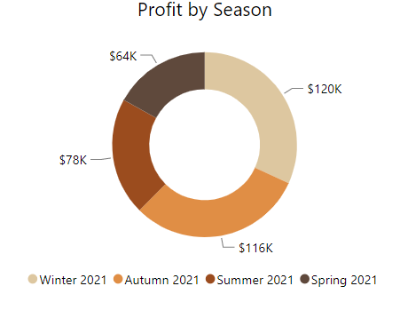

Figure 2 is a doughnut chart. It shows the total profit made in each season. The Winter season made the highest profit of $120K. The profit in Autumn made the 2nd highest profit of $116K. The profit in Summer made $78K. The profit in Spring made the lowest profit of $64K. Since we only have the data from January to October, the Spring season doesn't have the

Figure 2

profit data for November and the Summer season doesn't have the profit data for December.

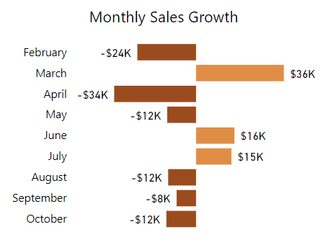

Figure 3 is a clustered bar chart. It shows the Month-Over-Month Sales growth. February, April, May, August, September, and October have negative growth while March, June, and July have positive growth. The month which had the highest sales growth was March and the month with the lowest sales growth was April.

Figure 3

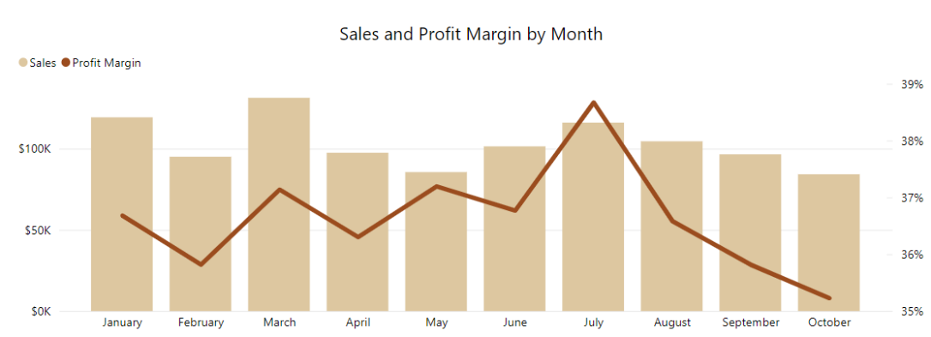Figure 4 is a line and clustered column chart. The column chart represents the sales per month while the line chart represents the profit margin by month. The month which resulted in the greatest sales was March while the month which resulted in the lowest sales was October. However, there is insufficient data for sales in October as only the sales until 24th October is recorded so the last week of October was not included in the dataset. The month which resulted in the highest profit margin is

Figure 4

July with a profit margin of 38.67% and the month which resulted in the lowest profit margin is October with a profit margin of 35.23%.

Figure 5 is a card. It shows that the total number of customers from January 2021 to October 2021 is 1000.

Figure 5

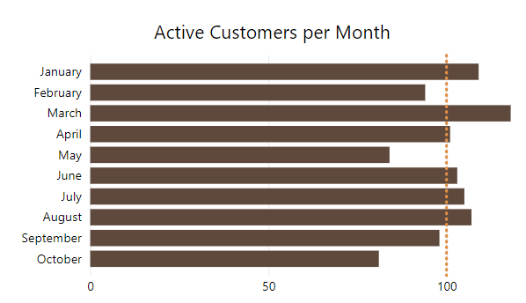Figure 6 is a clustered bar chart. It shows the No. of Active Customers per month. March has the highest number of active customers while October has the lowest number of customers. The average number of active customers is 100. So, the months that have a higher number of active customers than the average are January, March, April, June, July, and August. Meanwhile, the months that have a lower number of active customers than the average are February, May, September, and October. The winter season in Australia is during June, July, and August and during this period the number of customers is above the average number of active customers as customers buy winter clothing to prepare for winter.

Figure 6

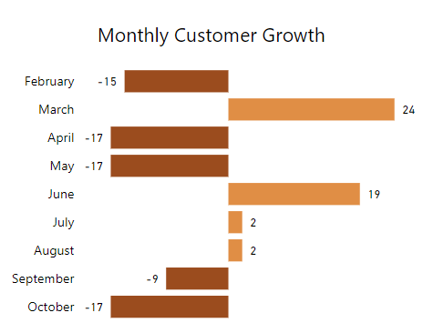

Figure 7 is a clustered bar chart. It shows the Month-Over-Month No. of Customers growth. February, April, May, September, and October have negative growth while March, June, July, and August have positive growth. The month which had the highest

No. of Customers growth was March and the month with the lowest No. of

Figure 7

Customers' growth was April, May, and October with all of them having the same growth of -17.

Figure 8 is an area chart. The green area represents the No. of customers per month while the blue area represents the Sales per month. This graph was used to show the trend between the No. of customers and sales. The visualisation shows that whenever there is a decrease in the No. of customers, there will be a decrease in sales and whenever there is an increase in No. of customers, there will be an increase sales. This shows that the No. of customers is directly proportional to sales. Therefore, to boost our sales and improve the performance of PUCCI, we have to attract more customers to PUCCI and make PUCCI more attractive than our competitors.

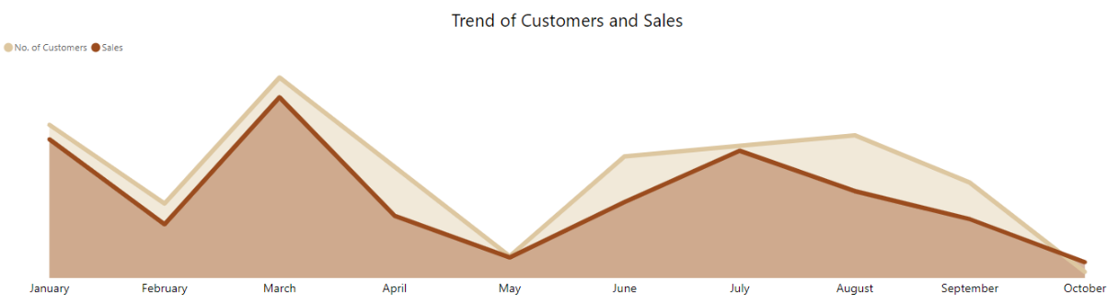

Figure 8

Figure 9 is a line chart. The yellow line represents the No. of customers in each age group while the blue line represents the profit made by each of the age group. The age group of 55-60 has the highest number of customers while the age group of 30-35 made the highest number of profits. Teenagers and adults are PUCCI's main customers as they contribute the most profit to PUCCI. Therefore, PUCCI can attract more teenagers and adults through PUCCI's marketing campaigns. Moreover, it will be a good opportunity for PUCCI to expand its services and products to children and babies too.

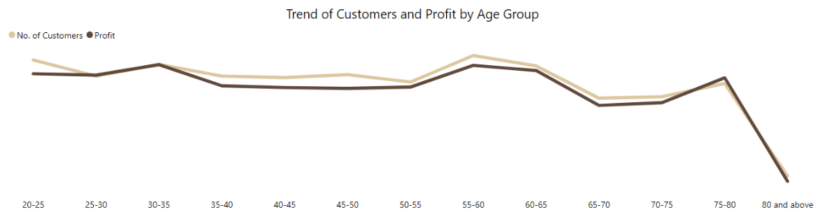

Figure 9

Figure 10 is a KPI. It currently shows the actual sales and the target sales in October. The actual sales in October was $84K but the target was $95K. Since the sales did not meet the target, the actual sales are shown in red colour. The graph in the background shows the actual sales from January to October.

Figure 10

Figure 11 is a line chart. The green line shows the actual sales per month from January to October. The blue line shows the target sales from January to December. The months where sales exceeded the targets were January, February, March, April, May, July, and September while the months where sales were lower than the targets were June, August, and October. June and August did not meet the target as those months were the winter season and PUCCI expected to sell more winter clothing. However, our No. 1 competitor GERMES, made a new winter clothing outfit which was more comfortable and therefore a lot of customers were attracted to GERMES product than PUCCI's product. Therefore, during the winter season, which is from June – August, we did not make as much sales as we expected. Moreover, October did not meet the target sales as there is insufficient data for sales in October as only the sales until 24th October is recorded so the last week of October was not included in the dataset. We expect the sales in November and December to be $130K and $150K respectively. We expected it to be high as December was going to be the start of the summer season and therefore, we expect that customers will start to buy summer outfits to prepare for the summer season in December. Additionally, we are launching new collections in December which will attract more customers leading to more sales. Further information on the new collection will be covered by the Marketing Manager. Moreover, December has many festivals such as Christmas and New Year's Eve therefore increasing the number of customers and thus increasing the sales. Therefore, PUCCI expects the sales in November and December to be high.

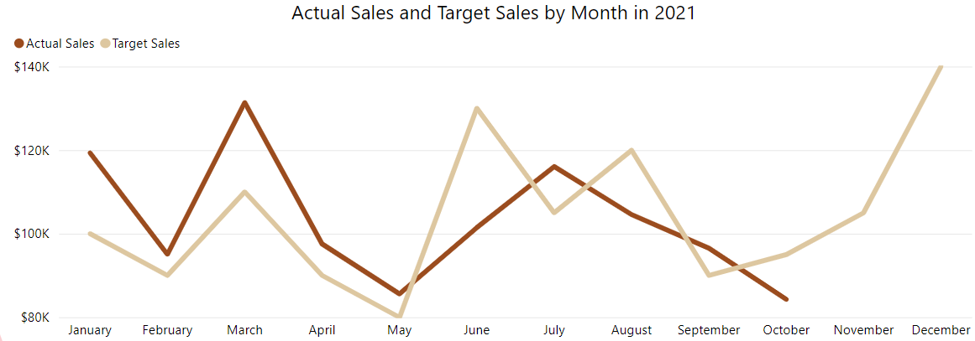

Figure 11

Figure 12 is a KPI. It currently shows the actual No. of customers and the target No. of customers in October. The actual No. of customers in October was 981 but the target was 90. Since the No. of customers did not meet the target, the actual No. of customers is shown in red colour. The graph in the background shows the actual No. of customers from January to October.

Figure 12

Figure 13 is a line chart. Figure 1.14 is a line chart. The green line shows the actual No. of customers per month from January to October. The blue line shows the target No. of customers from January to December. The months where No. of customers exceeded the targets were January, February, April, May, August, and September while the months where No. of customers were lower than the targets were March, June, July, and October. The actual No. of customers in March was 118 while the target was 120 so March did not meet the target by a very small amount. June and July did not meet the target as those months were the winter season and PUCCI expected to sell more winter clothing. However, our No. 1 competitor GERMES, made a new winter clothing outfit which was more comfortable and therefore a lot of customers were attracted to GERMES product than PUCCI's product. Therefore, during the winter season, which is from June – August, we did not attract as much customers as we expected. Moreover, October did not meet the target sales as there is insufficient data for No. of customers in October as only the No. of customers until 24th October is recorded so the last week of October was not included in the dataset. We expect the No. of customers in November and December to be $130K and $150K respectively. We expected it to be high as December was going to be the start of the summer season and therefore, we expect that customers will start to buy summer outfits to prepare for the summer season in December. Moreover, December has many festivals such as Christmas and New Year's Eve therefore increasing the number of customers. Therefore, PUCCI expects the No. of customers in November and December to be high.

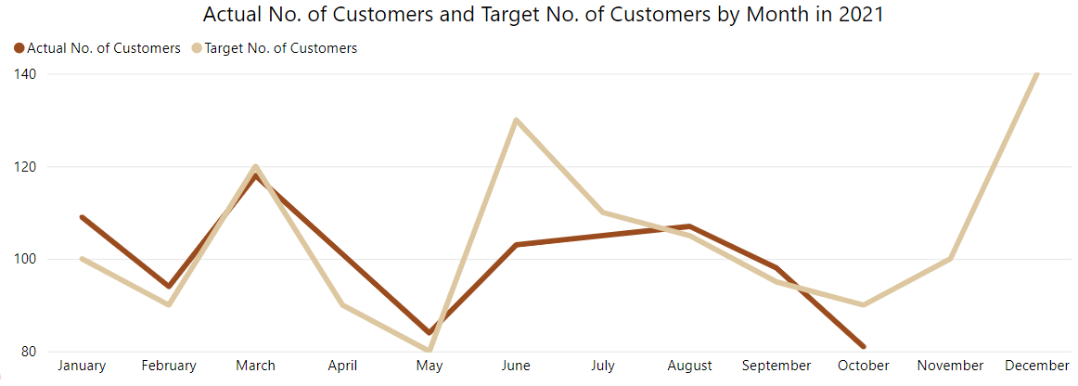

Figure 13

Overall PUCCI has performed very well. This could be due to the COVID pandemic which began in China in January 2020 and escalated to the whole world in the second half of 2020. The COVID-19 virus is still prevalent in Australia in the year 2021 which resulted in the Australian Government to impose several lockdowns. This resulted in Australian citizens not being able to buy clothing in retail shops. Therefore, they had to use e-commerce platforms like PUCCI to buy clothing. This led to the rise of e-commerce platforms including PUCCI as the demand for it grew due to the pandemic

## Dashboard

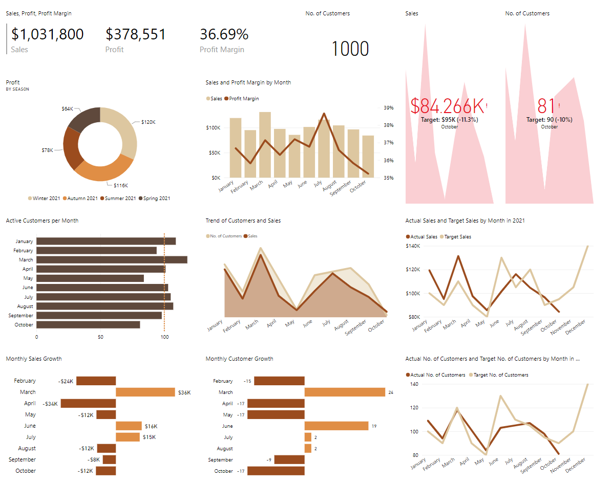

Figure 14

This dashboard for PUCCI's CEO should be able to convey the financial performance, customer information, target, and trends of PUCCI as these are the matters that a CEO will be interested in.

The CEO is interested in the financial situation so he will want to know the profit, sales, and profit margin of the PUCCI. By knowing this information, the CEO should be able to allocate capital in consideration of factors like net income, cash flow, and the valuation they wish to achieve. Therefore, I included a doughnut chart to show profit by season, a line and clustered column chart to show sales and profit margin by month, a clustered bar chart to show the Month-Over-Month Sales growth and a multi-row card visual to show the total sales made from January 2021 to October 2021, the total number of profits made from January 2021 to October 2021 and the overall profit margin from January 2021 to October 2021. These visuals enable the CEO to know exactly how PUCCI performs financially in each season and month. This allows him/her to find out which months or seasons performed the best/worst and find out the factors that caused that to happen. By knowing the factors, the CEO could implement new policies or targets for PUCCI in the future to mitigate the factors that cause the profit margin to be low and encourage the factors that cause the profit margin to be high.

The CEO will also be interested in Customer information. Since PUCCI is a clothing company, customers are the most valuable source. So, for the number of customers to be high, the CEO should listen to customers' demands so that customers will be more willing to buy PUCCI's products and no other clothing company's products. Therefore, I included a clustered bar chart to show the No. of Active Customers per month, an area chart to show the trend of No. of Customers and Sales and a clustered bar chart to show the Month-Over-Month customers growth. These visuals enable the CEO to know the relevant customer information like knowing which month had the greatest number of active customers and which month had the least number of active customers.

The CEO will also be interested in target information of PUCCI. The CEO of PUCCI will want to know if PUCCI met the target sales and target No. of customers for each month and if we did not meet the target, he/she will be interested in the details that caused PUCCI to not reach the target. Moreover, the CEO would like to know what the expected sales and No. of customers in the future is. So, I used two KPIs. One of the KPI is used to show the monthly sales and it shows if PUCCI met the target. The other KPI is used to show the monthly No. of customers and it shows if PUCCI met the target. I also used 2 line charts. One of the line charts is used to show the actual sales from January 2021 to October 2021 and target sales from January 2021 to December 2021. The other line charts is used to show the actual No. of customers from January 2021 to October 2021 and target No. of customers from January 2021 to December 2021.

# Marketing Manager

## Stakeholder Background

The manager of Pucci's marketing team responsible for promoting the company's products to consumers. He is Pucci's expert on the market and consumer demands. He conducts market research and analysing market data.

The marketing manager will be giving recommendations for what products will be included in their new summer collection. He needs to know what customers would want in this collection. To find out, he needs to know which products are currently the most popular among customers. At the same time, he also needs to ensure that the products he recommends are profitable. Hence, he wants to know which products are currently the most profitable.

Past trends have shown that customers prefer a personalised shopping experience. Before launching their next marketing campaign, the marketing manager wants to understand the customers better to develop targeted marketing campaigns. He wants to know what type of customers Pucci attract. He will also need to identify what groups of Pucci’s customers are the most valuable, and hence should be targeted in marketing campaigns. He also has to ensure that Pucci has enough customers and continues to grow.

To summarise, the marketing manager wants to answer the following questions:

* What types of products do Pucci specialise in?
  + What types of customers will these products attract?
* What would customers want in Pucci's new summer collection?
  + Which products are the most popular among customers?
  + Which products are the most profitable?
* What groups of customers are the most valuable to Pucci?
* Are there enough customers?
* Is the customer base growing?

## Data Analysis and Visualisation

The first goal of the analysis is to understand the products sold by Pucci. The marketing manager will need in-depth knowledge of the products in order to develop effective marketing strategies.

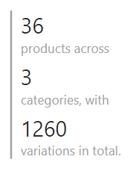

Figure 15 Products card

Figure 16 is a multi-row card that tells us the number of products at Pucci. 36 products are split into 3 categories: jackets, shirts, and trousers. Each product is available in 5 sizes and 7 colours, leading to 1260 variations in total.

Figure 16 Number of products by price range

Figure 16 shows the number of products offered by Pucci at different price ranges. Pucci specialises in high-end fashion apparel, hence their products are rather pricy. 47% of their products are around $110. High prices means that Pucci's products are generally targeted at affluent customers. Affluent customers are more likely to be willing to pay more to get higher quality products. Pucci can afford to be adventurous in increasing their prices.

Figure Products sold by size

Figure Products sold by colour

Figure 17 and Figure 18 are bar charts showing the number of products sold by size and colour. The distribution is even, no size or colour out sells the others by much.

Next, our goal is to investigate what type of products customers want in Summer. We will be looking at the performance of our products in January and February 2021.

Figure 19 Top 5 most profitable jackets

Figure 17 is a bar chart showing the top 5 most profitable jackets of Pucci.

Figure 20 Sales volume and profit margin of jackets

Figure 18 is a line and column chart showing the sales volume and profit margin of jackets. Trench coat, windbreaker, and cardigan are both the 3 most profitable products and the 3 highest-selling products. Pullover jackets are also highly popular, yet its low profit margin keeps it from being the most profitable. Puffer jacket is the 6th most popular jacket, its high profit margin makes it the 4th most profitable jacket.

Figure 21 Top 5 most profitable shirts

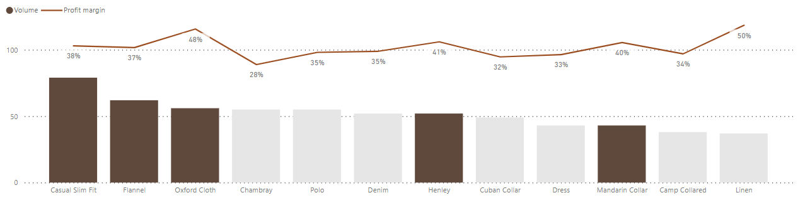

Figure 22 Sales volume and profit margin of shirts

Figure 23 Top 5 most profitable trousers

Figure 24 Sales volume and profit margin of trousers

Figure 21, Figure 22, Figure 23, and Figure 24 are similar to Figure 19 and Figure 20. In the shirts category, casual slim fit, flannel, and oxford cloth are the 3 most popular and profitable items. Henley is only the 7th most popular shirt, but its high profit margin makes it the 4th most profitable. Increasing the sales of Henley shirts via marketing will likely increase profit. In the trousers category, joggers is the most popular item and cropped is the most profitable item.

Overall, we see that "comfy style" items are especially popular with our customers during summer. After COVID-19 led to work from home, the fashion industry has seen an increase in the demand for casual and cosy outfits. The data shows that the demand for traditionally "stylish" items such as leather jackets, dress shirts, chinos trousers are low. Instead, the most popular items are the items made with soft and comfortable materials. However, many of these comfortable materials like wool, fur, and silk are animal-based. The new collection is an opportunity to create animal-free versions of these products.

Figure New customers by month

Figure 25 is a line chart showing the number of new customers each month. When the business first opened in January, we saw an influx of new customers. After 4 months, the trend has stabilised, and we see an average of 50 new customers per month.

Figure 26 Customers by number of orders made

Figure 26 is a bar chart showing the number of customers by the number of orders made. The higher the number of orders, the lesser the number of customers. 354 customers (57%) have only made 1 order.

Figure 27 Profit by customer group

Figure 27 is a treemap breaking down profits by customer group. Returning customers refers to the customers that have made 2 or more purchases.

Although only 43% of our customers are returning customers (Figure 3), they contribute 65% of Pucci's Profit. According to Harvard Business Review, acquiring a new customer can be 5 to 25 times more expensive than holding on to an existing one. This highlights that Pucci should invest in customer retention.

Figure Highest spending customers

Figure 28 is a bar chart showing the highest spending customers of Pucci. These customers are very valuable. It is beneficial to provide them with benefits to entice them to continue shopping on Pucci.

## Dashboard

The visualisations shown above can be split into 2 categories, product-related and customer-related. There will be 2 dashboards for the marketing manager, the product overview dashboard and the customer dashboard.

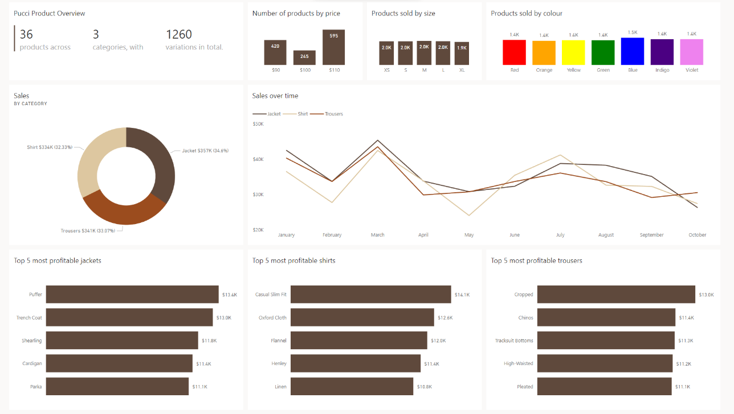

Figure 29 Product overview dashboard

The product overview dashboard (Figure 29) helps the marketing manager to quickly understand the products of Pucci. When designing this dashboard, the goal was to answer the following exploratory questions:

* What type of products do Pucci specialise in creating?
* What would customers want in Pucci's new summer collection?

The top row in this dashboard breaks down the products offered by Pucci. It shows the number products in each category and price range. It also shows the popularity of each size and colour. The second row breaks down sales by the 3 categories. This helps the marketing manager to quickly see how products in each category is performing. The last row shows the top 5 products in each category.

Figure 30 Customer dashboard

The customer dashboard (Figure 30) helps the marketing manager to identify groups of customers to focus on. When designing this dashboard, the goal was to answer the following exploratory questions:

* What groups of customers are the most valuable to Pucci?
* Are there enough customers?
* Is the customer base growing?

## Actionable Statements

The marketing manager will analyse the needs of customers in order to support the development Pucci's newest collection. He looks at the performance of the products, which reveals what the customers want. Based on the data, he recommends Pucci to design a series of apparel designed for comfort. This collection will be named "Comfy & Carefree".

The collection should include the following items:

|  |  |  |
| --- | --- | --- |
| Jackets | Shirts | Trousers |
| * Pullover * Cardigan * Trench Coat * Puffer | * Casual Slim Fit * Flannel * Henley | * Joggers * Cropped * Cords |

The items listed above have previously been made with animal-based products. However, in the "Comfy & Carefree" collection, new versions of these items are developed with plant-based and synthetic materials. This means that this collection is 100% cruelty-free.

Initially, the goal of the marketing manager was to develop strategies to attract new customers. To achieve this, the customer dashboard was created to help the marketing manager understand Pucci's customers. The data showed the marketing manager that returning customers are much more valuable than new customers. Hence, the goal has changed to developing strategies for keeping returning customers and converting one-time customers to returning customers.

One of the proposed strategies is a new loyalty program. The first part of this program is allowing customers to sign up as members. Members will receive emails each month about the latest deals and discounts at Pucci. After each purchase, members are rewarded with Pucci Points. Pucci Points can be used to offset the cost of future purchases. Highest spending members may be upgraded to a platinum tier membership, which offers double the amount of Pucci Points per purchase. This encourages customers to continue spending on Pucci in order to maximise the rewards.

# Sales Manager

## Stakeholder Background

Do you know who handles the unreasonable complaints of customers? It is none other than the sales manager. On top of solving customer-related issues, they also control the flow of goods and services by allocating sales territory, determining sales goals, and creating training programs for the company's sales representatives. Evidently, we can say that a sales manager requires lots of experience and must be equipped with many critical core skills such as communication and critical thinking to cater to their job scope. However, with so much work at hand, they often struggle to allocate time to obtain the company's performance as only raw data are being collected, and more meaningful data such as "profits" often requires calculation. My solution is to provide a quick and easy way for the sales manager to acquire the necessary sales information to boost the company's sales.

## Actionable Statements

The first question that always comes to a sales manager's mind is, Did the company profit? This is followed by a curiosity about the conditions when profits were the greatest and the various customers' preferences. Not to mention, a sales manager will surely question the ways to improve sales and the appropriate goal to set for the sales of the company.

Why will sales differ?

* As a sales manager, this is the most fundamental question that should be asked. Sales can be easily affected. This is especially given the globalised world, making everywhere more interconnected. What happens around the world can affect the sales of a company regardless of big or small.

What are the various customers' preferences?

* No one is the same, people usually have different preferences. Factors such as age and the place one lives affect their personal preferences. However, we can group the preferences according to the various factors making it easier to analyse the data.

What can I do to improve sales?

* Improving the sales of the company is the main role of a sales manager. They often have to analyse the various trends affecting sales and profits and come out with suitable suggestions for improvement.

What is an appropriate goal to set for the sales of the company?

* Setting goals is crucial for both short-term motivation and long-term vision. Employees lose the desire to strive for further advancements when there is no clear goal in mind for their work. As a result, goal setting is a common tactic used by sales managers to inspire their team members to boost sales and profitability of their business.

## Data Analysis and Visualisation

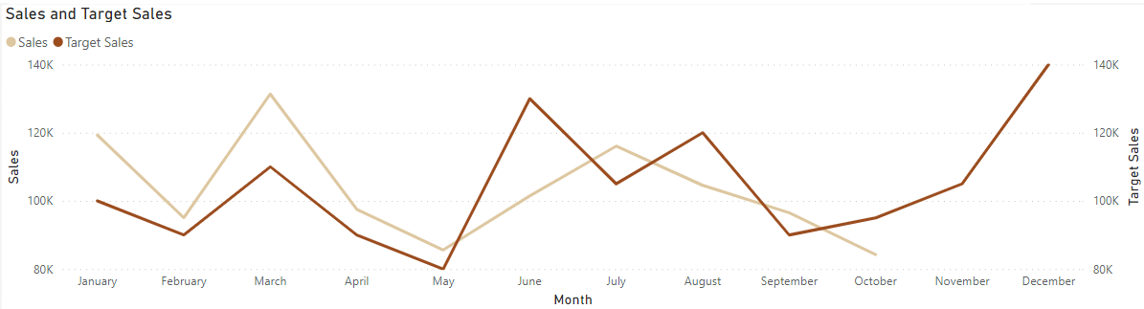

Figure 31 Sales and Target sales

Figure 27 shows the sales and target sales. For a sales manager, this visual is critical as it is needed to see if the target set was met. If the company did not meet the target, a sales manager will then have to provide reasons and suggest ways to improve the sales. Between June and August, we have mentioned the reason for not meeting the target sales in figure 11. Most people like discounts. So, the sales team has decided to have either a winter collection or a winter discount for the next winter season. This is to compete with GERMES and to increase our current sales to meet the target. Since we will be launching our new "Comfy & Carefree" Collection which is cruelty-free. We hope to see an increase in sales as we will be broadening our customer base, attracting animal lovers to purchase from our company. Furthermore, Australians are known for their love for wildlife and will surely like our products.

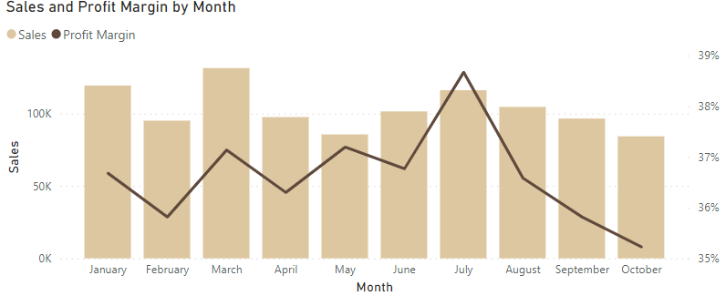

Figure 32: Sales and Profit Margin by Month

Figure 28 shows the sales and profit margin by month. The bar chart represents the sales, whereas the line chart represents the profit margin. This visual is crucial for a sales manager as we need to see if the company is earning or losing money. The lower the profit margin means the less we are earning per product. This is mainly due to people buying different products during different seasons and different products earn different amounts of profit, affecting profit margin.

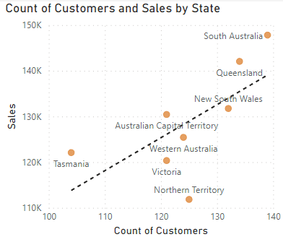

Figure 33: Count of Customers and Sales by State

Figure 29 shows the Count of Customers and Sales by State. The dotted line shows the trend of the number of customers against the number of sales per state. This is to see if the people in the different states are purchasing products from our company. This visual is important for a sales manager as the different states have a different number of customers and vary in how much they spend. Hence, this shows the importance of states as a factor affecting sales. For states that are below the trend line, especially Northern Territory we will check the trends of sales in that state, find the reason for such low purchasing rates, and present ways to improve sales in that particular state.

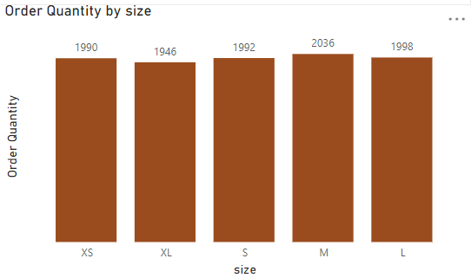

Figure 34: Order Quantity by Size

Figure 30 shows the Order Quantity by Size. The number above each bar in the bar chart represents the order quantity for each size. The higher the number, the more popular the size is. This visual is to compare and see if the sizes affect the sales. However, for most shops, the price of clothing is the same regardless of size. Furthermore, in this visual, we could see that the order quantity is about the same for all sizes. Hence, this visual main purpose is for a sales manager to know if there are any sizes that no one buys. If there are sizes with no sales, we will then need to reconsider the need to sell products with that particular size.

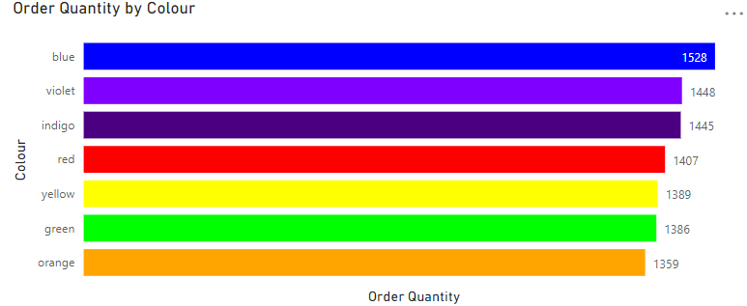

Figure 35: Order Quantity by Colour

Figure 31 shows the Order Quantity by Colour. The number beside each bar in the bar chart represents the order quantity for each colour. The higher the number, the more popular the colour is. This visual is to compare and see if the colours affect the sales. Similar to the size of products, very often the price of clothing is the same regardless of colours. Hence, this visual main purpose is for a sales manager to know if there are any colours that no one buys. If there are sizes with no sales, we will then need to reconsider the need to sell products with that particular colour.

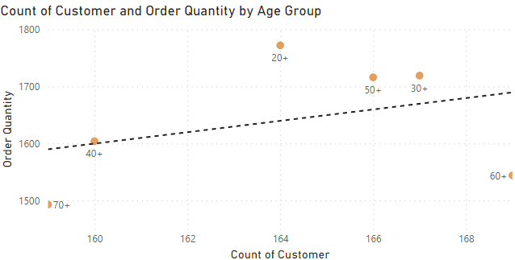

Figure 36: Order Quantity by Colour

Figure 32 shows the Order Quantity by Age Group. The dotted line shows the trend of the number of customers against the order quantity per age group. This visual is to compare and see if the age group affects the sales. From this visual I excluded the value of age group 80+ as there are very few customers within that age group, making it insignificant for data comparison. This visual is vital for a sales manager as the different age group spends differently. Hence, this shows the importance of age group as a factor affecting sales. For the age groups that are below the trend line, namely age group 60+ and 70+, we will check the trends of sales in that state, find the reason for such low purchasing rates, and present ways to improve sales for that particular age group.

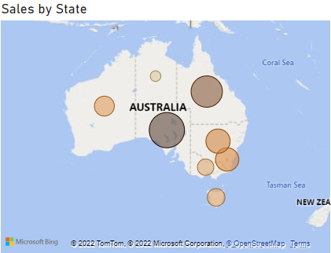

Figure 37: Sales by State

Figure 33 shows the sales by state. The size and colour intensity of the bubble represents the sales in each state. The bigger and darker the bubble, the greater the sales. This visual is to compare and see if the states affect the sales. This visual is important for a sales manager as the different states vary in how much they spend. Hence, this shows the importance of states as a factor affecting sales. For this case, we might use location-based pricing where we differ prices of items based on the states.

From the various factors above (size, colour, age group, and state), we could see that state is the greatest contributing factor affecting sales. As our new product will be launching in December, we will be looking at the statistics in Summer. Due to the conciseness of the report, we will only be looking at the state with the highest sales. According to the data given (January and February datasets), Western Australia has the highest sales in Summer.

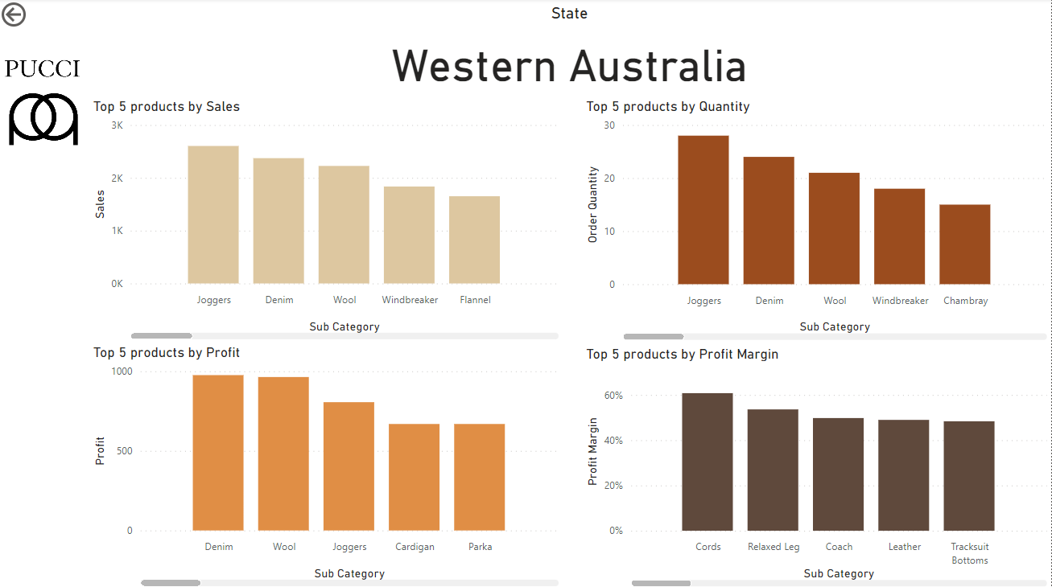

Figure 38: Top 5 products by Sales, Profit, Quantity and Profit Margin in Western Australia during Summer

Figure 34 shows the Top 5 products by Sales, Profit, Quantity, and Profit Margin in Western Australia during Summer. The main purpose of these visuals is for a sales manager to know what the popular items in the different states are. As shown by our marketing manager, our customers are overall affluent and are willing to pay high prices for the products. Hence, we would increase the prices according to the subcategory of the products so that we gain more profit and profit margin. Most people like discounts. We feel that the best few items to be discounted would be products in the top 5 profit margin visual. This is because, we feel sacrificing a little profit can return more order quantity and sales, which will ultimately increase the overall profit.

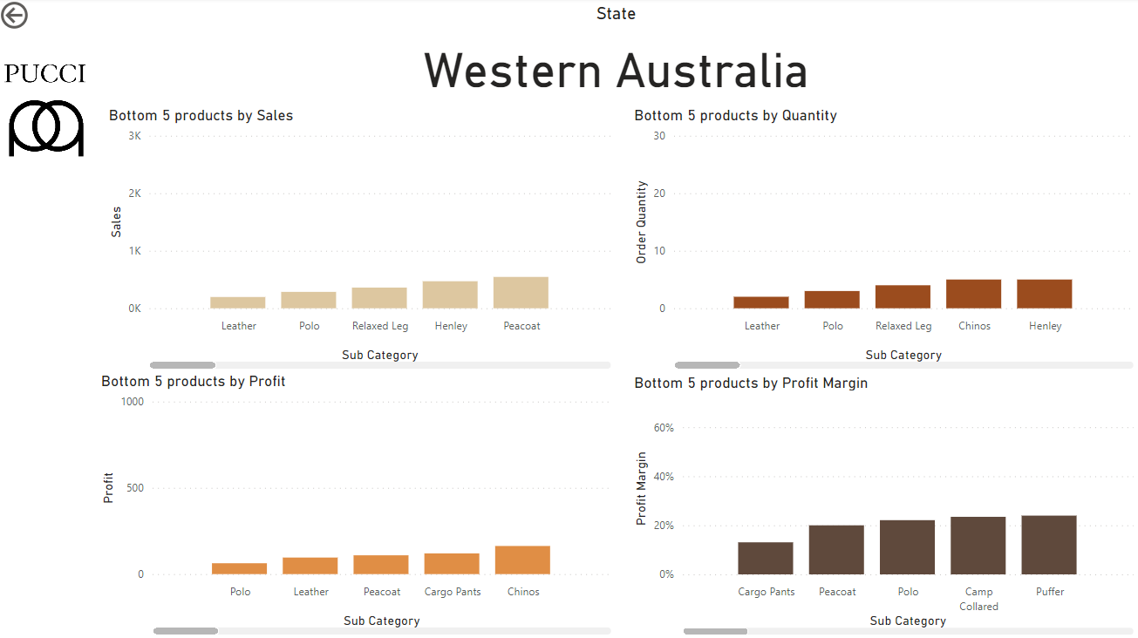

Figure 39: Bottom 5 products by Sales, Profit, Quantity and Profit Margin in Western Australia during Summer

Figure 35 shows the Bottom 5 products by Sales, Profit, Quantity, and Profit Margin in Western Australia during Summer. The main purpose of these visuals is for a sales manager to know what the less popular items in the different states are. So that we can come up with solutions to improve its sales. The sales team has decided to have discounts for the bottom 5 products by sales, order quantity, and profit provided it is not one of the bottom 5 products in terms of profit margin. By doing so, we can increase the order quantity of these items, hence increasing sales and profit for the company. Furthermore, this will decrease the number of leftover products in our inventory, which will be covered by our inventory planner in later parts of the report.

## Dashboard

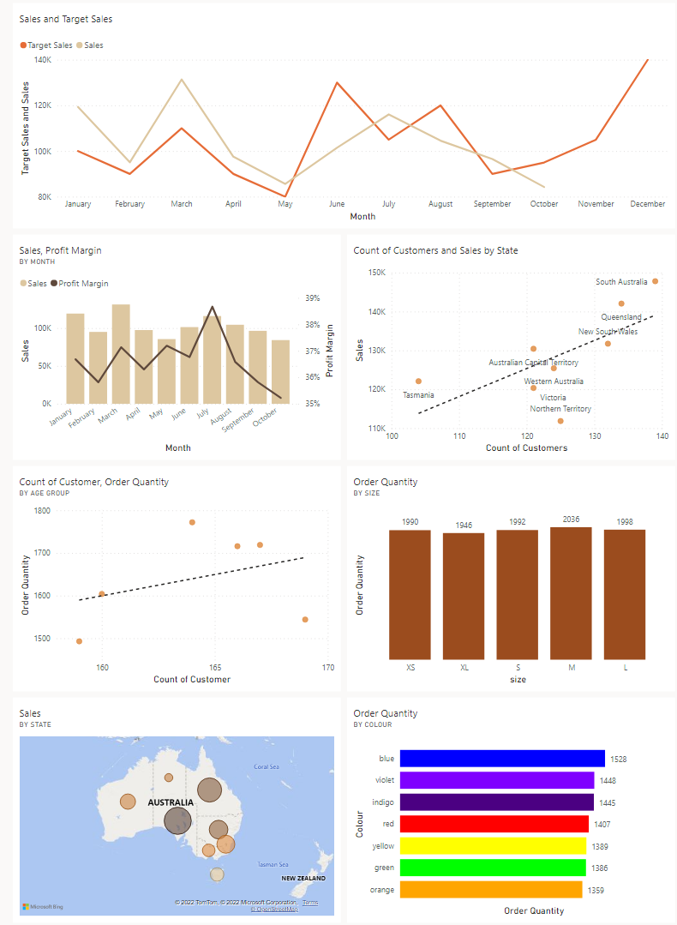

Figure 40: Sales by State

Figure 36 shows the overview and the factors affecting sales. This can help sales managers know what are the factors affecting sales. Allowing them to narrow down and better provide solutions to improve sales. In the first visual, we could see that the company did not meet the target between months June and August. Hence it is the sales manager's role to think of reasons for not meeting the target and to come up with solutions to improve sales during those months. In the second visual, we can see that the profit margin is high for July. The sales manager can perhaps opt in for a promotional month during July. By doing so, we can sacrifice a little profit which can return more order quantity and sales, ultimately increasing the overall profit. In the third visual, we could see that the Northern Territory is not doing very well in terms of sales despite having a greater number of people. Hence, this calls for a sales manager to think of ways to improve sales in that state. In the remaining four visuals, they are the factors that could possibly affect sales, namely the age group, the size, the state, and the colour. From these visuals, we could see that the age group and the state are the more significant factors affecting sales. However, if we were to filter via both factors, the data will be limited as PUCCI is only a new start-up company and lack sufficient data. As such, this may result in an improper analysis of sales of products. Hence, as a sales manager, I will adjust the prices based on state (location-based pricing). Only by doing so, then I will be able to optimise sales and increase profits.

# Purchasing Manager / Inventory Planner

## Stakeholder Background

Purchasing Manager

Now, the report will be providing a brief introduction of the occupation of the purchasing manager. So, what does being a purchasing manager entail? A purchasing manager, sometimes referred to as a purchasing director or supply manager, heads a team responsible for procuring goods and services for resale or company use. They seek the best available quality for the lowest price. They evaluate suppliers, negotiate contracts, and review product quality. That is generally what purchasing managers do but the responsibilities of purchasing managers can vary from one industry to another.

For example, those who work for manufacturing companies manage the purchasing of raw or minimally processed materials. This can include the purchasing managers who work for timber companies who have to manage the purchasing of raw wood. Those who work for wholesalers or retailers purchase finished goods can have multiple duties. These include studying the market to identify price trends and future availability of materials and goods, locating vendors, negotiating prices, preparing requisitions and purchase orders, and maintaining purchase records. However, there will be a team doing all these tasks lead by the purchasing manager. A purchasing manager for a clothing company would fall under the category of purchasing managers who work for retailers.

The report will now be addressing the skills required to work in this job. A number of skills are required to perform well in this job role. Firstly, financial management skills are essential to being a good purchasing manager. Having financial management skills allow them to make informed decisions about spending the company's budget when buying the goods. Some other skills a purchasing manager must have are good management skills, market researching tactics, negotiation skills, communication skills, and marketing capabilities. All these skills help in the various aspects of the job role.

Good managing skills ensure that they can lead their team well so that the company can avoid crisis situations and promptly solve problems such as getting poor quality goods. They must react fast and find solutions to these problems in a short time to avoid the company from facing a loss. These skills can be developed through learning and practical experience as a manager. Communication skills are also vital in ensuring the smooth operation of the company as the purchasing manager has to dispense his ideas to his team effectively and clearly.

Inventory Planner

The primary responsibilities of an inventory planner is to monitor and maintain the number of goods in the warehouses, managing orders to facilitate sales and production, signing off on shipments, counting the number of available products of each category and placing more orders according to the demand.

An inventory planner has to work with the purchasing manager to ensure that there is enough supply of goods. An inventory planner is incredibly important in an e-commerce business as there is no official store where consumers can buy their goods from and can only rely on online purchasing to buy their goods.

The inventory planner has to work with the purchasing manager to ensure that there is a sufficient supply of goods to meet the demand at all times. The inventory planner must communicate with the purchasing manager about the demands of the different products so that the purchasing manager can place orders for the necessary number of products needed. If the purchasing manager and the inventory planner work well together, there would be no problems in terms of the supply of the products.

Exploratory Questions

1. Can the supply of the goods meet the demand from customers?
2. Which category of our company's products is the highest selling?
3. What are the features that affect the number of products sold from each category?
4. How many of each of the products do I have to order in the future in order to save the company money while ensuring the inventory does not run out?

## Actionable Statements

1. The purchasing manager/ inventory planner must look at the quantity of goods purchased by customers at the end of every season. After looking at the number of goods, he must look at the data for the purchase of goods from other months too and analyse the trend of the purchase of the goods. Then, he has to make calculated decisions on the number of goods to purchase for the future months from the manufacturer. With these steps, he will be able to ensure that the supply of goods will meet the demand of the goods.
2. The purchasing manager/ inventory planner must determine the specific products that are the highest-selling so that he can place more orders more the higher-selling products and restock on these products more than the other products that might not be selling as much.
3. The purchasing manager/ inventory planner must also consider the different features that might affect the number of products sold from each category. Features can include colour and size of the products. Hence, the purchasing manager/ inventory planner can order a greater number of the products with the features that are more popular among customers.
4. The purchasing manager/ inventory planner must determine the number of products to order for the products in future collections by looking at the number of products sold previously and making a calculated decision, all while making sure of not overstocking to avoid dead stock, which is basically the inventory has held for a long time and will unlikely sell, and to avoid not wasting the money of the company.

## Data Analysis and Visualisation

Overview Page

This page shows some visuals that just give the general inform of what an inventory planner/purchasing manager must know.

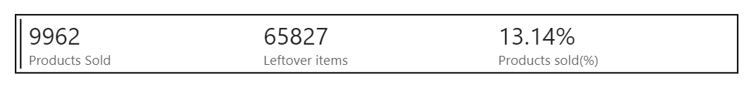

Figure 41

Figure 41 shows a multi-row card that conveys the general information the purchasing manager has to know such as the number of products sold, number of products left in the warehouses and the number of products that were sold as a percentage of the original number of products at the start of January. With this information, the purchasing manager can determine whether there is too much products leftover in the warehouse and whether the products are selling sufficiently. Then the purchasing manager can take steps to ensure that there is less number of products not sold and left to waste in the warehouse. In the above example, there is too much leftover items and this shows that the purchasing manager has to purchase less products in the future when the new collection is released.

Figure 42

Figure 42 shows a bubble map visual that shows the number of products sold in each state in Australia. The bigger the bubble, the greater the number of products sold at that particular place. The inventory planner would need this visual to determine the number of products that needs to be sent to the warehouse at each state. As seen from the visual, there are more products sold in the eastern part than the western part so the inventory planner will now know that he has to assign more products to the warehouses in eastern part of the country than the western part.

Figure 43

Figure 43 shows a line graph that shows the trend of popularity of the different categories of products by considering the number of products sold from each category. With this visual, the purchasing manager can see that trousers is the most popular category and shirt is the least popular category. Then, the purchasing manager can place more orders for trousers than shirt and jacket in the future.

Figure 44

Figure 44 shows a doughnut chart that shows the number of products sold and leftover items as a percentage of the original number of products at the start of January. This visual is a graphical representation of the information in the multi-row card in Figure 1. With this visual, the purchasing manager can better understand about the status of the number of products sold and leftover. In this example, there is too much leftover items as almost 87% of the original number items is leftover and only about 13% of the original number of items is sold. Hence, in the future, the purchasing manager can place an order for a lower quantity of items.

Leftover Items page

This page will feature visuals that show the quantity of leftover items by using different visuals that have different functions. This page also has 2 slicers, category slicer and season slicer to display more specific information so that the inventory planner/purchasing manager can derive more insightful conclusions.

Figure 45

Figure 45 shows a line and clustered column chart that shows the number and trend of the leftover items at the end of each season. The bar graph shows the number of items from each category at the end of each season and each bar is coloured a different colour to represent the different category. The colour that represents each category is highlighted in the legend. The line shows the trend in the leftover items at the end of each season. The steeper the line, the greater the number of products sold in that season. This visual shows that the greatest number of products were sold in Autumn. Since the inventory planner oversees restocking, with the help of this visual, the inventory planner can determine the number of products to restock at the end of each season. There are also 2 slicers on the page, one for category and one for season to allow the matrix table to show more specific information. When jacket is chosen in the category slicer, only the tan-coloured bars will be seen which is basically the bars for jackets and when a season is chosen, the information for that particular season will be seen.

Figure 46

Figure 46 shows matrix table that shows the specific number of leftover items from each sub-category of each category. This will allow the inventory planner to decide on the number of the specific products to restock. Conditional formatting is also applied to this visual where the darker the colour of the background in the category column, the less the leftover items in the warehouse and darker colours show the urgency to restock the items. If the quantity falls below, 1800, the colour will be dark brown and restocking is needed. There are also 2 slicers on the page, one for category and one for season to allow the matrix table to show more specific information. For example, when jacket is chosen in the category slicer, the matrix table will show the sum of products left for each sub-category and if summer 2021 is chosen in the season slicer, the matrix table will show the sum of the leftover items of the sub-categories at the end of summer 2021.

Figure 47

Figure 47 shows the number of leftover items in each state. I also applied conditional formatting to this dashboard. The darker the area, the lesser the number of items in the warehouse in that state. The darker colours indicate more urgency to restock. Slicers for category and season can also affect this visual. With this visual, the inventory planner can determine the number of products to restock based on state. In this example, South Australia needs urgent restocking as seen from the small bubble.

Quantity sold by Size page

This page will feature visuals that show the quantity and trend of products sold by size so that the purchasing manager can determine how many products of each size to purchase. This page also has the category and season slicer.

Figure 48

Figure 48 shows a column chart that shows the number of products sold in each size. As seen from this visual, M is the most popular size while XL is the least popular size. The purchasing manager can then place the most orders for M size clothes and least orders for XL size clothes. Similar to the leftover items page, this page also has the category slicer and season slicer to allow the line graph to show more specific information.

Quantity sold by colour

This page will feature visuals that shows the number and trend of the number of products sold by colour so that the purchasing manager can determine the number of products of each colour to purchase.

Figure 49

Figure 49 shows a line and clustered column chart that shows the number of products sold by each colour. The graph shows the sum of the number of items of each colour sold in each category. The different colours represent the different categories as shown in the legend at the top. The line also shows the trend of the number of products sold from each colour more clearly. From this visual, the purchasing manager can see that blue was the most popular colour and orange was the least popular colour. Then in the future, the purchasing manager can place the orders for each colour based on the trend as seen in the graph above. Like in the previous pages, there is the category and season slicer in this page.

Inventory Target

This page will feature visuals that show the target quantity for inventory for the new collection that will be released in December when the summer season starts. There are only a few products that will be sold in this collection that was decided by the marketing manager which is why the purchasing manager will only purchase these specific items. Unlike the previous pages, this page will only feature the category slicer as the visuals on this page only show information for 1 season, so the season slicer is not applicable to this page.

Figure 50

Figure 50 shows a column chart for the target quantity of the different sub-categories that is involved in the new collection.

## Dashboard

Figure

Figure shows the dashboard for the inventory planner/ purchasing manager. This dashboard shows a mixture of visuals for the number of products sold and number of products left in the warehouses. This dashboard features more of the more important visuals from the report that conveys important information that the inventory planner/purchasing manager needs to know to make future decisions such as the quantity of products to purchase for the future.

This dashboard includes visuals for the quantity of products sold, the features of the product that affect the quantity of products sold such as colour, the number of leftover items left in the warehouses and the inventory target for the upcoming collection that the company is about to release.

As seen from the dashboard, there is too many leftover items and this would help the inventory planner/ purchasing manager to purchase a lower quantity of items in the future which is why the inventory target is less. The inventory target is for 3 months which is why the numbers are so small. The sub-categories from each category which had the most amount of items left were cord trousers, leather jacket and mandarin collared shirt. Hence, the purchasing manager/ inventory planner would like to suggest to the sales manager to hold a sale for these items and give heavy discounts for these items so that people will be more encouraged to buy these items. Hence, less of these items will be wasted. The sale can also include the other sub-categories to clear the warehouses of the older items to make space for the newer items.

# Logistics Manager

## Stakeholder Background

Logistic managers take care of deliveries and monitors outgoing and incoming goods. They budget and track expenses used for deliveries'. They are responsible for making delivery more efficient. Warehouse need to ensure that the supply chain is running and hence has to know how many items we have in stock

1. How do I ensure that goods reach customers efficiently and safely?
2. Where are most of our customers located?
3. What are the shortest routes from our warehouse that we can use to deliver goods to our customer?
4. What are the budget I can use to improve the efficiency of our supply chain?

## Actionable Statements

1. I can check the number of deliveries each driver has done and give bonuses to those that have done the most deliveries. This will motivate other employees to work harder to obtain the bonus.
2. I can send more drivers to the locations where our customer base is the densest and use that to allow deliveries to be more efficient. I can also use this to plan out the most effective routes
3. I can use this information to save on the company's costs, allowing our deliveries to be cost efficient and taking less of the budget for transportation
4. I can find out where our suppliers are located and work with the purchasing manager to facilitate deliveries from the factory to our warehouses.
5. I can find the number of deliveries made each month and see whether it

## Data Analysis and Visualization

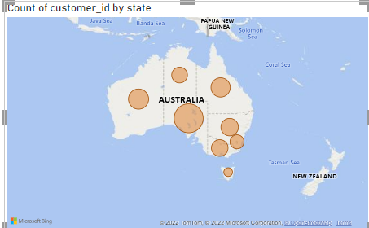

Figure

Figure 52 is important to optimise delivery times for my employees. This is because due to the density of customers in each state of Australia I can send more of my driver there.

This will reduce the time taken for deliveries and grow the company's reputation along with it

Figure 48 shows the total deliveries and which deliveries on time. Looking at the data I can interpret those 14 days is the amount of time we guarantee customers will receive their products

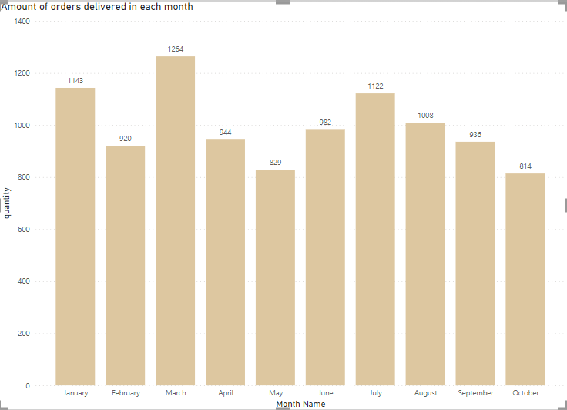

Figure

Using Figure 53 know the number of orders being delivered each month in order to predict the delivery times. Moreover, with the release of the new product I can estimate how the increased sales will affect my delivery time for the product.

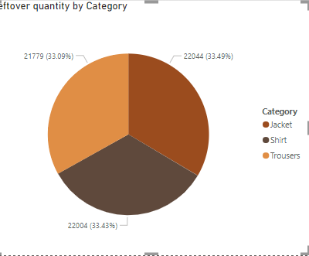

Figure

Figure 54 is used to ensure that I have enough items in the warehouses for delivery. This is because having not enough items could lead to a disruption in the supply chain.

6.4 Dashboard

My dashboard explores how many items are left in stock and the number of deliveries on time. This also shows I could do a lot better to optimise my delivery time. I will first start by collecting clock in times of employees and number of deliveries they did. Then I will reward the employee doing the most deliveries with a small bonus. Moreover, I'll need to think of how to optimise my routes in each state of Australia. Finally, I'll have to find the general items in stock so can distribute goods the most cost and time efficient way. It will also be good if we ma aged to gather feedback from customers about our goods as I would like to ensure a seamless delivery process

# Group Reflection

In the past few weeks, our 5 group members worked together to perform exploratory analysis on the data of an apparel e-commerce shop. There were some challenges we had to overcome during the process.

Firstly, working with insufficient data was difficult for us. For this assignment, we were only given 4 flat files of data. We had many ideas that could not be implemented as we did not have the required data. For example, there is no data on customer feedback. This made it hard to evaluate if customers were satisfied with the products and services provided by Pucci. This information is very valuable as it can provide insights on how the logistics manager and sales manager can improve their departments. In addition, the business was only open from January 2021 to October 2021. The short time meant that we did not have enough data to forecast what is going to be the likely sales for next year. Some data were also incomplete. For example, in the month of October, there was no data for sales above 24th October. So, there is one week of data missing in October. Therefore, most of the visuals show October having the least sales and profit margin but this is in fact inaccurate as this occurred because of the missing data in October.

Secondly, transforming raw data was a big challenge. The raw data was not enough for many things we wanted to do and we had to clean and transform the data to gain meaningful insights. For example, when we loaded the excel data to PowerBI, there was data such as cost_per_unit, quantity and total_price. These raw data alone is not able to give any useful information. So, we had to use measures and DAX to use these raw data to make more useful information like Profit and Profit Margin.

We had to use some of the given datasets given to make new types of data values for us to create our visuals. For example, we had to make use of the 'Create Measure' and 'Create Quick Measure' functions for us to make new data values. In the 'Create Measure' function, we had to manually create the formula for the new datasets that we desired. In the 'Create Quick Measure' function, we only had to select the datasets that we needed for the new dataset and choose from the existing methods for us to create the function.

For example, to obtain leftover inventory, we had to subtract total quantity of products sold from the original quantity of products and this could be done by creating a new quick measure as the formula is not too complicated. However, to obtain the leftover inventory for only a number of months, we had to create a measure manually that considers the months also and filters the months according to the number of months needed. We had to google for the Dax codes to create some of the new datasets we needed, and we were quite new to the world of Dax codes. In the past practicals, we were not exposed to Dax codes that often and during the time we had to use a Dax code, the code was given to us and all we needed to do was copy paste the code. By doing this, we were not exposed to many of the functions in the Dax code and did not really understand how to create Dax codes at first.

As a result, when we first found out that we had write DAX codes as part of the assignment, we were excited but nervous at the same time. We were excited to see how the DAX codes worked but were nervous as we were writing DAX codes for the first time and did not want to mess up our visuals by using DAX codes. However, every time our DAX codes worked the way we wanted it to work, we felt extremely satisfied with ourselves and happy as our hard work paid off.

We believe that writing DAX codes has been an essential skill that we have mastered that is crucial for the jobs this course is preparing us for. Our dream jobs that include the data analyst, business analyst and data scientist require the use of data most of time and we would have to manipulate the data to create visualisations as part of the job roles.

Thirdly, when our group was analysing the data, we realised that we lacked much of the business knowledge required. As a result, there were things we did not know how to explain. Even though we could see whether the company's profit is increasing or decreasing, we could not explain why. It was also challenging to come up with recommendations or strategies. We had to do a lot of research to make up for the lack of business knowledge. Consultation with the tutor was also helpful.

Next, time management is another challenge we faced. As a group of five, we all have varying commitments and free time. As such, we often find it difficult to decide on a specific time when we could all meet and discuss the project. For example, on Wednesdays, we are all in different classes for the Interdisciplinary Studies (IS) module. This has resulted in us being unable to meet on Wednesdays as the timing for our modules is different. Furthermore, we are given many assignments, leaving us with little or no free time. Over the next two weeks, we have about five major assignments from different modules that make up a significant portion of the overall grade.

Lastly, we had to improve our communication and teamwork. Initially, w often did not ask other members for help. We lacked communication skills when expressing our ideas to each other. We also lacked the courage to ask for help when faced with challenges. However, sometimes when we got to know each other we were more open with our struggles in PowerBI and the datasets. It was only through this that we were able to do our report and dashboard. We all learnt the importance of teamwork and communication for our ideas to be cohesive and applied in our reports and dashboards.

# Individual Reflections

## Law Jun Jie

In the recent Fundamentals for IT Professional presentation, I mentioned that I wanted to be a data analyst when I grew up. Having done this assignment has surely enhanced the skills required to be a data analyst in the future.

Personally, I have been doing my Data Science Fundamentals weekly assignments faithfully, following every single step with caution. However, I did them with no understanding. As a result, when we were given this major assignment for our Data Science Fundamentals module, I panicked and quickly went back to redo all the assignments that we had done in the past weeks. However, this time was different. I performed every single step with understanding. To my horror, it took me two whole days to complete everything. With that being said, I was happy as I finally understood how to use Power BI with little help. This has resulted in me having a much easier job doing the visuals for the assignment. Undeniably, this has brought me a step closer to my future job as a data analyst.

Another lesson that I took away from this group assignment was teamwork and effective communication. I feel that this group is the best group one can be in. Although most parts were based on individual marks, all the group members will actively help one another and even suggest improvements for each other. There were many occasions when one of us needed help. But our group has never failed to lend a helping hand, sharing DAXes and many more. This gave me an eye opener about what good teamwork is. As a future data analyst, I would need to work with my fellow data analyst to analyse sets of data and may encounter differences in opinions. Hence good teamwork and effective communication are critical core skills I must acquire. After this assignment, I can confidently say that it has surely benefitted me by honing the required skills for a data analyst.

In conclusion, this group assignment has certainly benefitted me a lot, shaping me to become a better data analyst in the future.

## Akul Arun

I think that this assignment was incredibly important and helpful in my journey of achieving my dream job which is to be a business intelligence analyst. A business intelligence analyst must manipulate data and create visuals for companies and through this assignment I have been able to improve my data manipulation skills and data visualisation skills which are very crucial skills for qualifying for the job role.

By learning how to create the DAX codes and the quick new measures, I had developed my data manipulation skills as I had to use the current datasets that I had in hand to create a formula to derive the new dataset that I had to use for the particular visual that I had to create. However, at first, I didn’t know how to create DAX codes, but with the help of friends and YouTube, I figured out how DAX codes work. Although, I have used some DAX codes in my visual, I would not say my skills are supreme and I still there is room for improvement for me.

I had to show my understanding of the roles and responsibilities of the particular stakeholder I chose by conveying information that is useful to my stakeholders through the visuals that I had created. This improved my data visualisation skills as I had to convey an idea through graphical means. Whenever I needed help figuring out how to create the visuals, I would just refer back to the practical guides made by the teachers which gave me in-depth information and step-by-step guidance which really helped me when creating the visuals. I also asked my lecturer for help through the numerous consultations that were held, and he was able to clear my doubts that I had. He also made sure that I was working well with my group by regularly checking up on us. Hence, I am thankful to have such a great lecturer who was both caring and helpful.

I also improved my communications and interpersonal skills through this group work. I had to discuss and share my ideas to my group, and I also had to made sure they understood what I was trying to tell them. This improved my effective communication skills. I also forged better friendships with my groupmates as we had spent quite a long time and blood, sweat and tears while doing this project. I am thankful that I was in this group that was full of hardworking people who always pushed me to create better visuals by giving me comments and ideas on my visuals.

All in all, this assignment and the module of Data Science Fundamentals was extremely helpful and fun as it provided me with a better understanding of the field of work I aim to pursue. I would like to thank the lectures for making this module fun by spending so much time on preparing the numerous labs work that we had to do. Doing these labs were also much more helpful then just reading the slides as it helped more in our learning. The experience in this module will always hold a special place in my heart.

## John Wong

In Data Science fundamentals, I learnt many aspects that are related to my future course of study data science. Through the tutorials on powerBi I learned how to use software to make eye-catching visuals that tell a story to the user. I learned how to fully utilise data to achieve my end goals. Although I faced many challenges in this assignment, for example not enough data in the csv file provided related to my job roles. I learnt how to be resilient and come up with insightful visuals to help the company and its situation.

I learnt a lot about how to use Dax expressions in powerBI and I'm really grateful to have such an understanding lecturer to help me in my job role. I also found the optional tutorials on powerBi useful to me to learn more and improve my report and dashboard.

In summary, I think this module will prepare me greatly for my future course data science as they teach the fundamentals of using data to achieve your goals. It also increased my interest in the course of data science.

## Pranav Vijitharan

My future plan is to become a data scientist and I am sure that the Data Science Fundamentals (DSF) module has given me the necessary skills and abilities to become one. In this section, I would like to explain the technical and soft skills that I have learned throughout this module and how I am going to use these skills in the future.

Firstly, I learned how to think out of the box and come up with great solutions and meaningful insights. During the Design thinking tutorial and the DSF Assignment, I had to really process the data and understand my stakeholder's background. At first, I had a tough time coming up with insights and solutions as all of my thoughts were narrow and were not good. However, as time began to progress, I began to dig deeper into the data and find out something that would be meaningful for a business. I began to unravel each of the factors that impact a business one by one and I was able to come up with better business strategies and insights. I was able to expand my thinking, and this prevented me from keeping my thoughts and ideas narrow. Hence, this module helped me think out of the box and come up with great business ideas. This can help in my future career which is being a Data Scientist. This is because a Data Scientist is expected to give great ideas to solve problems in the company therefore, they require the skill to think out of the box.

I also learnt how to use DAX code which is very useful for data analysis. Usually, data at first is at its raw form and using raw data for data analysis is pointless as usually nothing can be derived from raw data. Therefore, by using DAX code, it can enable me to get more useful data. For example, when I loaded the excel data to PowerBI, there was data such as cost_per_unit, quantity and total_price. These raw data alone is not able to give any useful information. So, I had to use DAX to use these raw data to make more useful information like Profit and Profit Margin. Using profit and profit margin is better for data analysis rather than cost_per_unit, quantity and total_price. Moreover, DAX is a very important tool used by Data Scientists so learning DAX is very crucial for me to become a Data Scientist.

In conclusion. DSF has given me the necessary technical and soft skills to become a Data Scientist. All the assignments and lab practical were incredibly important as they gave me experience on how to use PowerBI better. All in all, the DSF module was really great and gave me the experience I need to become a good Data Scientist.

## Lee Jia Wei Shawn

For me, a key takeaway from this module is that creating value from data is not only about the technical challenges. Other than having technical skills such as knowing how to use Power BI, we also need to understand the business side of things well. At the start of the module, I was only focusing on using the different tools I learnt to manipulate and visualise the data. The resulting visuals were ineffective in communicating a message. I found the lesson on Design Thinking in week 5 to be helpful. It helped me to understand that data science is not just about playing with numbers on a computer, it is about addressing the needs of people.

Even though my future career goal is not being a data analyst, I believe what I learnt in module will be beneficial in the future. I want to build Machine Learning (ML) models. ML is about finding patterns in data, which means that knowing how to extract, transform, and load data is a key skill in ML engineering. In the week 7 practical activity, I learnt to load data from a SQL database into Power BI. Later, I practised transforming this data into a usable form using Power Query and DAX. I will continue to build on this foundation in my future modules such as Databases and Distributed Data Pipelines.